# Cancer Detection Using Deep Learning Approach

Rania Elgohary 1, Mostafa Tarek1, Mohamed EzzAlRegal1, Abdulrahman Ahmed1, Amr Samir1, Nour Ehab1, and M.B. Badawy 1,2, *

1Department of Artificial Intelligence, College of Information Technology, Misr University for Science

and Technology (MUST), 6th of October City 12566, Egypt.

2Mechanical Engineering Department, Faculty of Engineering, Alexandria University, El-Chatby, Al-

exandria 21544, Egypt.

* Correspondence author(s). E-mail(s): mohammed.badawi@must.edu.eg,

Contributing authors: [Rania.elgohary@must.edu.eg](mailto:Rania.elgohary@must.edu.eg), [mostafat4438@gmail.com](mailto:mostafat4438@gmail.com), [mezz7409@gmail.com](mailto:mezz7409@gmail.com) [abdulrahmn477@gmail.com](mailto:abdulrahmn477@gmail.com), [amrsalatif@gmail.com,nourehaab21@gmail.com](mailto:amrsalatif@gmail.com,nourehaab21@gmail.com)

***Abstract:*** This study explores advanced computational techniques for medical diagnostics, focusing on skin cancer and brain tumor detection and segmentation. It involves developing a website, desktop application, and Streamlit app to enhance early detection and precise delineation of these health conditions.

Using datasets like HAM1000, PH2, and LGG, the study employs Convolutional Neural Networks (CNNs) and U-Net models to accurately interpret medical imaging data. This integration of machine learning algorithms and large datasets aims to improve diagnostic accuracy and treatment planning.

The study highlights the importance of combining technology with clinical expertise to address healthcare challenges, demonstrating how modern computational methods can revolutionize diagnostic processes and improve patient outcomes.

***Keywords*:**Localization, Classification, Segmentation, Cancer Detection, Cancer DataSets.

# INTRODUCTION

To address the growing global concern of skin cancer, this study aims to enhance diagnostic methods by leveraging advanced deep learning techniques. Skin cancer, including melanoma and basal cell carcinoma, is a significant public health challenge with its prevalence steadily increasing due to factors like sunlight exposure, genetic predisposition, and lifestyle choices. Early detection and accurate classification of skin lesions are crucial for effective treatment, and novel solutions are urgently needed to meet the rising demand for precise diagnostics. This research utilizes Convolutional Neural Networks (CNNs) and extensive datasets such as HAM10000 and PH2 to tackle these challenges. By integrating medical expertise with cutting-edge technology, this study proposes a comprehensive approach that includes a segmentation model to precisely delineate lesion boundaries, potentially revolutionizing skin cancer diagnosis. The incorporation of CNN-based methods, informed by a wealth of previous research, promises to improve diagnostic accuracy and contribute significantly to dermatological healthcare.

Additionally, this paper highlights the critical role of MRI in diagnosing neurological disorders and the need for accurate segmentation of brain MRI images for clinical applications. Convolutional Neural Networks, particularly the U-Net architecture, have shown remarkable success in medical image segmentation. This study employs a U-Net-based approach, enhanced by a custom loss function and data augmentation techniques, to optimize segmentation accuracy. By building on existing methodologies and integrating sophisticated network layers and preprocessing techniques, this research aims to improve the detection and classification of brain tumors, ultimately aiding radiologists in clinical decision-making and improving patient outcomes.

# METHODOLOGY

4.4.1. Data Collection

The datasets used in this research are "HAM10000" and "PH2". The "HAM10000" dataset contains 10,015 skin cancer images, each sized at 450x600 pixels. The "PH2" dataset consists of 200 skin lesion images, each 768x560 pixels. Both datasets are in RGB color format.

4.4.2. Data Preprocessing

HAM10000: Images were resized to 28x28 pixels. The dataset was then split into 80% training and 20% testing sets. Both sets were normalized. A label mapping dictionary was created, associating seven class names with keys 0 to 6 for classification tasks.

PH2: Images were resized to 224x224 pixels. The dataset was split into 80% training and 20% testing sets to ensure balanced distribution. This resizing ensures compatibility with models requiring uniform input dimensions.

Brain LGG (Low-Grade Glioma) dataset: MRI images and masks were resized to 256x256 pixels and normalized to a [0, 1] range by dividing by 255. Binary mask thresholding was applied: pixel values above 0.5 were set to 1 (tumor), and values 0.5 or below were set to 0 (background).

4.4.3. Data Augmentation

HAM10000: To address class imbalance, various augmentations were applied, including rotation, width shift, height shift, shear, and horizontal and vertical flips.

PH2: Random rotations and horizontal flips were used to augment the dataset, introducing variations.

4.4.4. Model Architecture

Classification using the HAM10000 dataset: The model has twelve layers. It starts with convolutional layers to capture intricate image patterns. The initial layer uses sixteen filters, followed by a max-pooling layer for down-sampling spatial dimensions. This pattern repeats with increasing complexity using 32, 64, and 128 filters in subsequent convolutional layers. Figure 1 shows the classification model architecture, and Table 4.1 lists the hyperparameters for the classification methodology.

**Figure 1: Proposed Classification Model Architectural Framework.**

Segmentation using the PH2 dataset: The model includes one encoder and one decoder pathway. The encoder has four convolutional layers followed by max-pooling for down-sampling, increasing complexity with depth. Each convolutional block consists of two convolutional layers with batch normalization and ReLU activation. Figure 2 shows the model architecture.

**Figure 2: Segmentation Model Architectural Framework.**

Segmentation using the LGG dataset: The model architecture is based on a U-Net structure as shown in figure 3, and it includes an encoder-decoder framework with skip connections to facilitate the propagation of detailed information from earlier to later layers.

**Figure 3: Segmentation Model Architectural Framework.**

# FINDINGS

Results for Skin Cancer Classification

DeepConvNet achieved the highest accuracy, precision, and recall scores, indicating its effectiveness in classifying skin cancer lesions (see Table 1 and Figure 4). Auto Encoder had a relatively high precision but lower accuracy and recall compared to DeepConvNet, suggesting difficulty in correctly identifying some instances. CNN decay lr, VGG16, ResNet50, InceptionV3, and Xception showed varying performance levels, with their scores falling below those of DeepConvNet but still demonstrating some effectiveness in skin cancer classification.

**Table 1: Performance Analysis: Metric Comparison across Training Algorithms.**

|  |  |  |  |
| --- | --- | --- | --- |
| Training Metrics | | | |
| Model Name | Accuracy | Precision | Recall |
| DeepConvNet | 99.5 | 99.5 | 99.5 |
| Auto Encoder | 70.17 | 82.26 | 58.09 |
| CNN with decay lr | 81.23 | 89.72 | 73.28 |
| VGG16 | 67.13 | 84.03 | 54.65 |
| ResNet50 | 66.99 | 66.99 | 66.99 |
| InceptionV3 | 66.97 | 85.86 | 54.2 |
| Xception | 66.8 | 85.92 | 54.31 |

**Figure 4: Performance Analysis: Metric Comparison across Training Algorithms.**

Table 2 and Figure 5 show that the DeepConvNet outperformed all other testing algorithms in terms of accuracy, precision, and recall, demonstrating its ability to accurately categorize skin cancer lesions.

**Table 2: Performance Analysis: Metric Comparison across Testing Algorithms.**

|  |  |  |  |
| --- | --- | --- | --- |
| Testing Metrics | | | |
| Model Name | Accuracy | Precision | Recall |
| DeepConvNet | 97.204 | 97.5 | 97.2 |
| Auto Encoder | 70.17 | 82.49 | 58.17 |
| CNN with decay lr | 73.64 | 81.1 | 67.9 |
| VGG16 | 66.99 | 83.52 | 60.03 |
| ResNet50 | 66.83 | 66.83 | 66.83 |
| InceptionV3 | 66.89 | 85.19 | 60.58 |
| Xception | 66.73 | 83.29 | 61.04 |

**Figure 5: Performance Analysis: Metric Comparison across Testing Algorithms.**

Results for Skin Cancer Segmentation

In Table 3 and Fig 6, the U-Net model's performance metrics are examined across both training and testing datasets. The U-Net model achieves high accuracy, precision, recall, Dice Coefficient, and IoU scores, underscoring its efficacy in accurately segmenting skin cancer lesions.

**Table 3: Performance Analysis: Metric Comparison across Training and Testing Sets.**

|  |  |  |  |  |  |
| --- | --- | --- | --- | --- | --- |
| Training Metrics | | | | | |
| Model Name | Accuracy | Precision | Recall | Dice Coefficient | IoU |
| U-NET | 96.68 | 95.39 | 94.24 | 93.58 | 97.09 |
| Testing Metrics | | | | | |
| Model Name | Accuracy | Precision | Recall | Dice Coefficient | IoU |
| U-NET | 96.14 | 93.44 | 94.09 | 92.55 | 96.43 |

**Figure 6: Performance Analysis: Metric Comparison across Training and Testing Sets.**

Proposed Skin Cancer Models Predictions

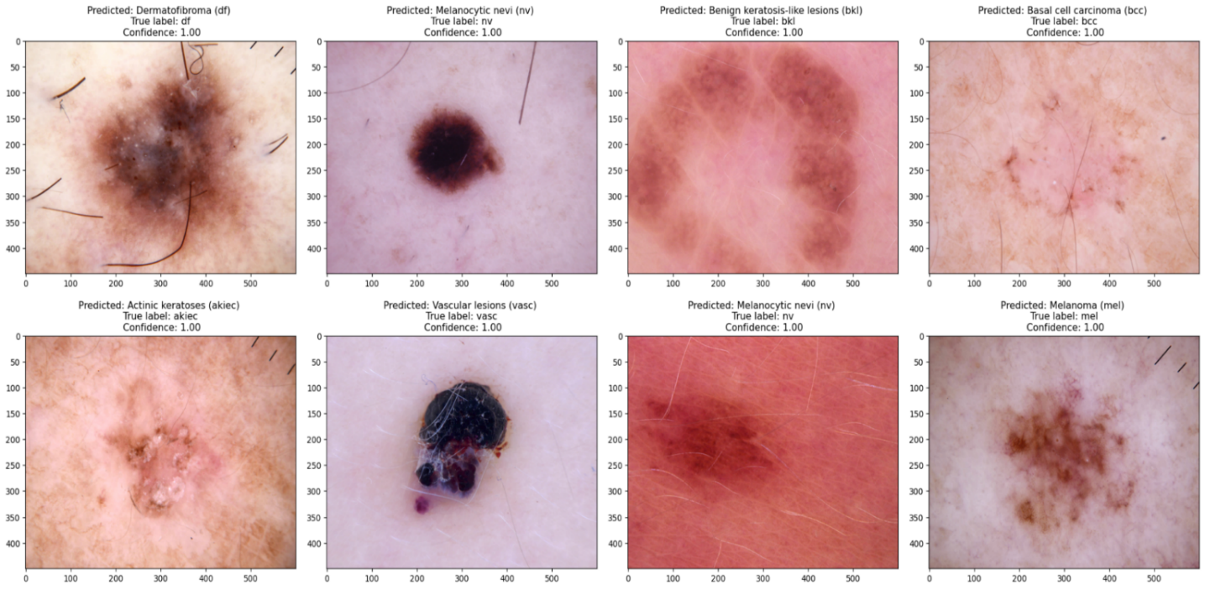In Figure 7, several predictions from the suggested model are showcased, demonstrating its performance in classifying skin cancer lesions. When the model predicts accurately, the confidence level typically falls within the 97%–100% range. Figures 8 and 9 display predictions from the U-net segmentation model.

**Figure 7: Sample classification predictions from the suggested model.**

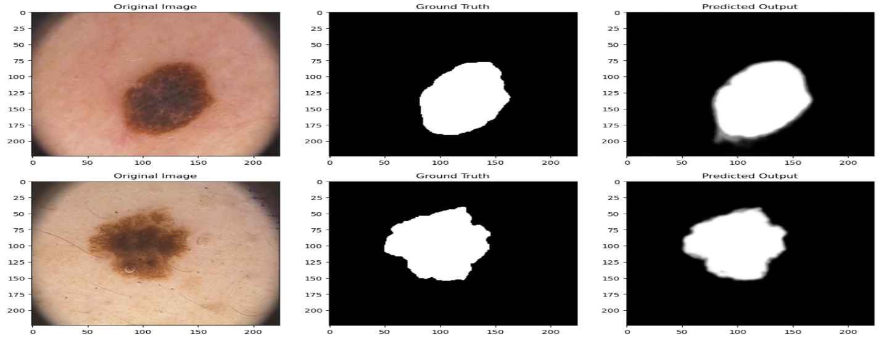**Figure 8: Sample predictions from the segmentation model.**

Combining segmentation and classification models enhances skin cancer diagnostic systems. The segmentation model accurately defines lesion boundaries, isolating affected areas. These segmented regions are then localized and sent to the classification model for further analysis. Figure 9 illustrates this process, showing how segmented lesions are identified and classified to determine the specific type of skin cancer. This integrated approach leverages segmentation for precise delineation and classification for accurate diagnosis, improving the efficiency and reliability of skin cancer detection.

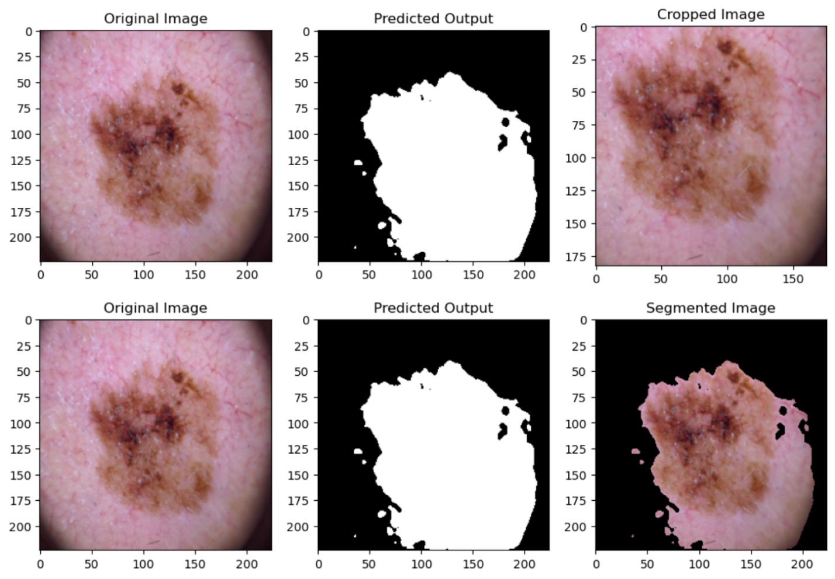**Figure 9: Segmentation-Driven Skin Cancer Diagnosis Model**

Results for Brain Tumor Segmentation

Tables 4 and 5, along with Figures 10 and 11, present a comprehensive analysis of the performance metrics of the U-Net model across training and testing datasets. Demonstrating remarkable accuracy, Dice Coefficient, and IoU scores, the U-Net model underscores its effectiveness in precisely segmenting Brain Tumors.

**Table 4: Performance Analysis: Metric Comparison across Brain Training Set.**

|  |  |  |  |
| --- | --- | --- | --- |
| Training Metrics | | | |
| Model Name | Accuracy | Dice Coefficient | iou |
| U-NET | 0.9986 | 0.9276 | 0.8675 |
| Attention ResUNet | 0.9985 | 0.9182 | 0.8501 |
| inceptionv3 | 0.9976 | 0.886 | 0.7999 |
| resnet50 | 0.9981 | 0.9014 | 0.8248 |
| resnext50 | 0.998 | 0.9014 | 0.8245 |

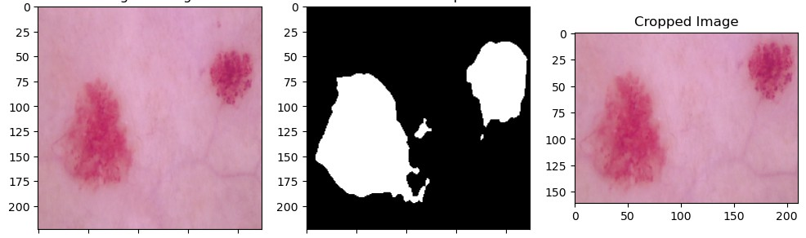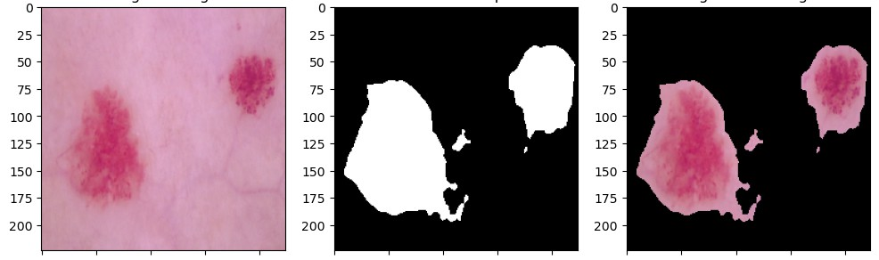

**Figure 10: Performance Analysis: Metric Comparison across Brain Training Set.**

**Table 5: Performance Analysis: Metric Comparison across Brain Testing Set.**

|  |  |  |  |
| --- | --- | --- | --- |
| Testing Metrics | | | |
| Model Name | Accuracy | Dice Coefficient | iou |
| U-NET | 0.9984 | 0.9127 | 0.8411 |
| Attention-Res-UNet | 0.9982 | 0.9022 | 0.8252 |
| inceptionv3 | 0.9975 | 0.8673 | 0.7698 |
| resnet50 | 0.9977 | 0.8801 | 0.7898 |
| resnext50 | 0.9976 | 0.8721 | 0.7783 |

**Figure 11: Performance Analysis: Metric Comparison across Brain Testing Set.**

Proposed Brain Tumor Model Predictions

Figure 12 shows a sample prediction from the best-trained U-Net model, demonstrating its accuracy in segmenting brain tumors. The image highlights the model's capability to delineate boundaries and identify areas of interest, showcasing its robust performance and potential for aiding in the automated diagnosis and treatment of brain tumors.A screenshot of a video game

**Figure 12 Sample prediction from the Brain segmentation model.**

# CONCLUSIONS

This study advances medical diagnostics by utilizing technology to tackle skin cancer and brain tumors. Through the development of a website, desktop application, and Streamlit app, the project enhances early detection and precise localization of these diseases.

Utilizing datasets like HAM1000 and PH2 for skin cancer classification and the LGG dataset for brain tumor segmentation, the project combines machine learning algorithms with user-friendly interfaces to offer significant benefits to patients and healthcare professionals.

Key to this approach are advanced deep learning models, such as Convolutional Neural Networks (CNNs) and U-Net, which extract detailed patterns from medical images for accurate skin lesion classification and brain tumor segmentation. This fusion of deep learning with large datasets significantly improves diagnostic accuracy, enabling timely interventions and personalized treatments.

As technology and medicine increasingly intersect, this work highlights the potential of modern computational techniques and the importance of interdisciplinary collaboration in addressing complex health issues, ultimately aiming to improve patient outcomes and quality of life.

# REFERENCES

[1] S Panda, AS Tiwari, MR Prusty. Comparative study on different Deep Learning models for Skin Lesion Classification using transfer learning approach. International Journal of Scientific and Research Publications. 2021;11(1):219-32.

[2] Y Wang, Y Wang,J Cai, TK Lee, C Miao, ZJ Wang. Ssd-kd: A self-supervised diverse knowledge distillation method for lightweight skin lesion classification using dermoscopic images. Medical Image Analysis. 2023 Feb 1;84:102693.

[3] Aldhyani TH, Verma A, Al-Adhaileh MH, Koundal D. Multi-class skin lesion classification using a lightweight dynamic kernel deep-learning-based convolutional neural network. Diagnostics. 2022 Aug 24;12(9):2048.

[4] S Maqsood, R Damaševičius. Multiclass skin lesion localization and classification using deep learning-based features fusion and selection framework for smart healthcare. Neural Networks. 2023 Mar 1;160:238-58.

[5] B Shetty, R Fernandes, AP Rodrigues, R Chengoden, S Bhattacharya, K Lakshmanna. Skin lesion classification of dermoscopic images using machine learning and convolutional neural network. Scientific Reports. 2022 Oct 28;12(1):18134.

[6] MS Ali, MS Miah, J Haque, MM Rahman, MK Islam. An enhanced technique of skin cancer classification using deep convolutional neural network with transfer learning models. Machine Learning with Applications. 2021 Sep 15;5:100036.

[7] V Anand, S Gupta, A Altameem, SR Nayak, RC Poonia, AK Saudagar. An enhanced transfer learning-based classification for diagnosis of skin cancer. Diagnostics. 2022 Jul 5;12(7):1628.

[8] TM Alam, K Shaukat, WAKhan, IAHameed, LA Almuqren, MA Raza, M Aslam, S Luo. An efficient deep learning-based skin cancer classifier for an imbalanced dataset. Diagnostics. 2022 Aug 31;12(9):2115.

[9] S Aladhadh, M Alsanea, M Aloraini, T Khan, S Habib, M Islam. An effective skin cancer classification mechanism via medical vision transformer. Sensors. 2022 May 25;22(11):4008.

[10] RD Seeja, A Suresh. Deep learning-based skin lesion segmentation and classification of melanoma using support vector machine (SVM). Asian Pacific journal of cancer prevention: APJCP. 2019;20(5):1555.

[11] A Tajerian, M Kazemian, M Tajerian, A Akhavan Malayeri. Design and validation of a new machine-learning-based diagnostic tool for the differentiation of dermatoscopic skin cancer images. PLoS One. 2023 Apr 14;18(4):e0284437.

[12] B Wang, P Geng, T Li, Y Yang, X Tian, G Zhang, X Zhang. A deep model towards accurate boundary location and strong generalization for medical image segmentation. Biomedical Signal Processing and Control. 2024 Feb 1;88:105623.

[13] MN Trinh, VD Nguyen, VT Pham, TT Tran. An EffcientNet-encoder U-Net Joint Residual Refinement Module with Tversky–Kahneman Baroni–Urbani–Buser loss for biomedical image Segmentation. Biomedical Signal Processing and Control. 2023 May 1;83:104631.

[14] S Jin, S Yu, J Peng, H Wang, Y Zhao. A novel medical image segmentation approach by using multi-branch segmentation network based on local and global information synchronous learning. Scientific Reports. 2023 Apr 25;13(1):6762.

[15] MA Naser, MJ Deen. Brain tumor segmentation and grading of lower-grade glioma using deep learning in MRI images. Computers in biology and medicine. 2020 Jun 1;121:103758.

[16] Q Yang, H Zhang, J Xia, X Zhang. Evaluation of magnetic resonance image segmentation in brain low-grade gliomas using support vector machine and convolutional neural network. Quantitative Imaging in Medicine and Surgery. 2021 Jan;11(1):300.

[17] S Ghosh, A Chaki, KC Santosh. Improved U-Net architecture with VGG-16 for brain tumor segmentation. Physical and Engineering Sciences in Medicine. 2021 Sep;44(3):703-12.

[18] Z Liu, L Tong, L Chen, Z Jiang, F Zhou, Q Zhang, X Zhang, Y Jin, H Zhou. Deep learning based brain tumor segmentation: a survey. Complex & intelligent systems. 2023 Feb;9(1):1001-26.

[19] F Özyurt, E Sert, E Avci, E Dogantekin. Brain tumor detection based on Convolutional Neural Network with neutrosophic expert maximum fuzzy sure entropy. Measurement. 2019 Dec 1;147:106830.